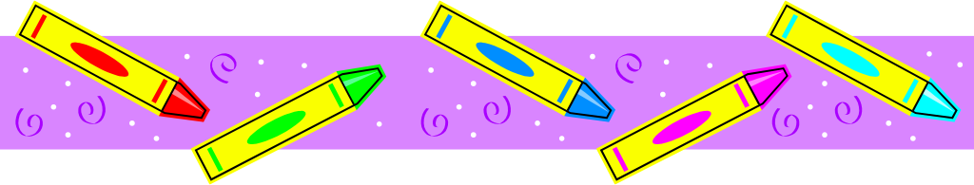
Supply List – September 2022-2023
Mrs. Hoxhaj
Grade 1
4 composition notebooks (there must be a margin with lines to write on from top to bottom)
4 packages #2 Ticonderoga pencils
1 black felt tip pen or fine tip Sharpie pen
1 large box Crayola crayons
1 package Crayola washable markers
1 pair child sized Fiskar scissors
2 packages Elmer’s glue sticks (4 or more glue sticks package)
2 sharpeners with receptacle
2 packages eraser tops
2 green two pocket poly folders
1 package EXPO markers
4 boxes of Kleenex tissues
3 Clorox tubs of disinfecting wipes
1 plastic pencil box for crayons, scissors & other items (place your child’s name on this box)
1 backpack with NO wheels
1 package white printer paper
1 clipboard
1 pair headphones for computer and laptop use (these stay in school)
1 bottle of Hand Sanitizer
1 refillable water bottle

Grade 2
Please purchase ALL of the above and add/change:
2 blue two pocket poly folders (instead of green)
1 large homework pad (lined)

Grade 3
Please purchase ALL items in first grade section and add/change:
2 red two pocket poly folders (instead of green)
1 large homework pad (lined)
Third graders do not need to purchase a clipboard or headphones (you should have from last year).

●Keep your store receipts! Please label all items with your child’s first and last name. Some items will be placed in a community basket for all students to share.

**ALL STUDENTS: Please have your child create a collage on one composition notebook (back and front) using family photos, pictures from magazines, favorite foods, places, words and pictures from vacation brochures, etc. Please use a glue stick. This will be your child’s writer’s journal. I have an example to look at, if you are unsure of what is needed. Due 9/7/2022!

•If your child has any food allergies, or takes medication that we need to know about, please send an updated note/prescription from your doctor to explain.

● Please provide extra snacks and an extra drink each day for snack time. The teacher will not provide snacks.

•Please purchase a set of supplies to keep at home; for homework and project purposes. (Pencils, construction paper, a sharpener, crayons, glue, scissors, and a ruler).

